**Newton’s Skateboard Name** Dessa Shapiro

**Introduction/Background:** What happens to an object when you pull or push steadily on it? Your intuition and life experience may not guide you to the whole truth on this (apparently simple) question. For several thousand years the world’s greatest thinkers were wrong about it. It took Isaac Newton to set us straight in the 1600’s. He said: **F = ma**

**The experiment:**

A science teacher at your school sat on a skateboard. She plus the skateboard weighed <71> **kg**. Another teacher pulled her across the floor with a constant force of **10 Newtons**, using a Newton spring scale to pull. Every second we marked her position on the floor using chalk. Here’s what we got:

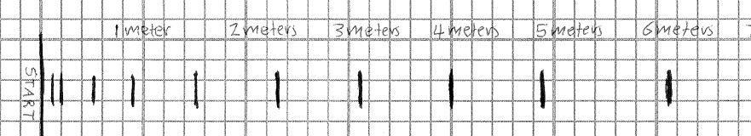

[Create a spreadsheet](https://docs.google.com/document/d/1PaboQCBymEq11Z8EqG5KGPhAYC0x3okQUbZccNE0oLI/edit?usp=sharing) that allows you to calculate the data and create the graphs needed for this experiment.

Take a cropped screenshot of your data table from the spreadsheet and place it below.

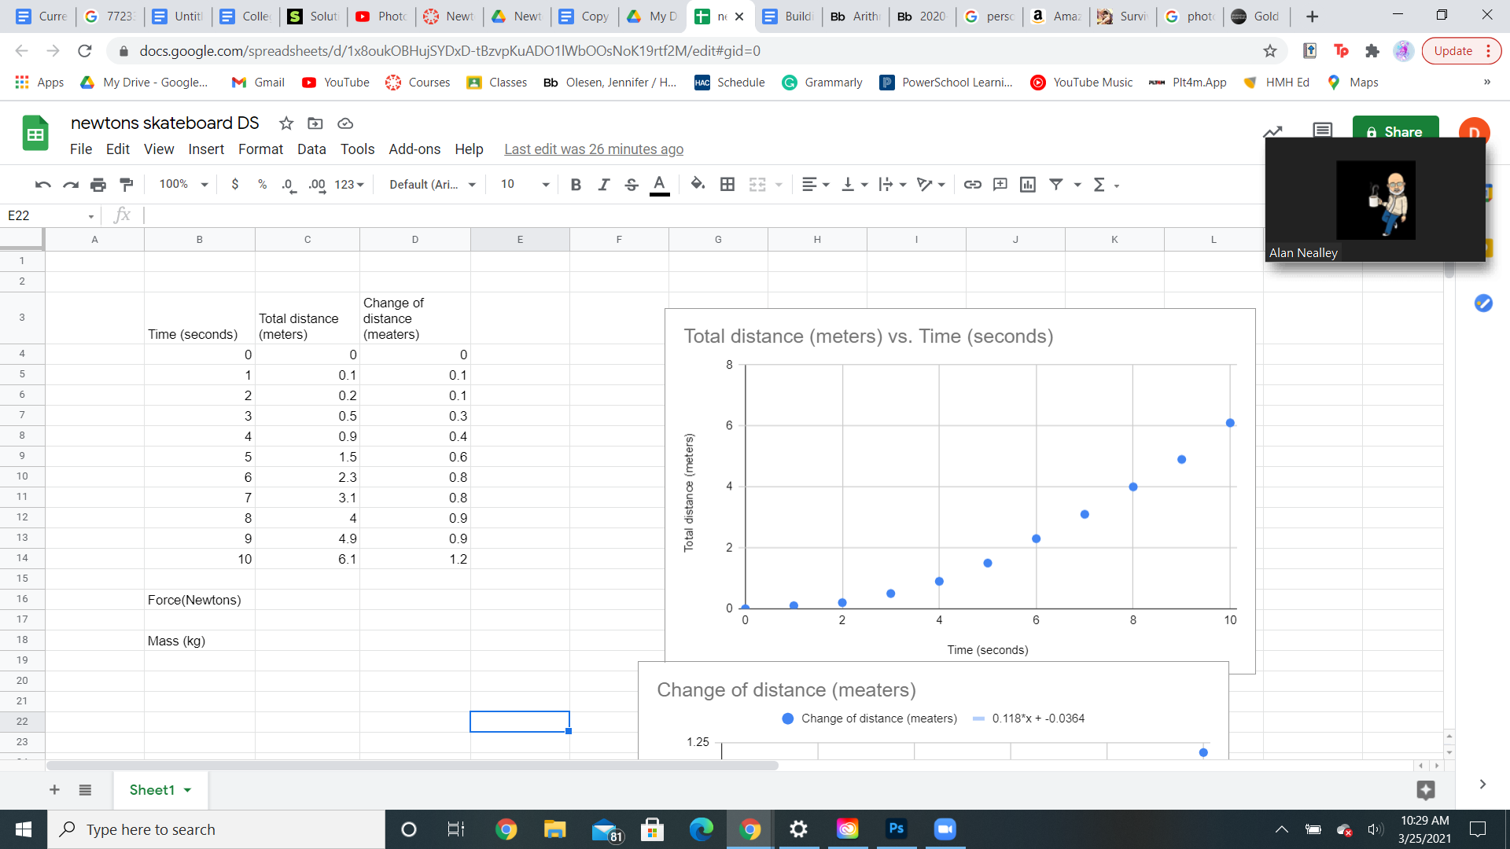

Using your spreadsheet, make a well-labeled graph of **distance vs. time** for the skateboard/sitter. Put time on the X-axis.



**Acceleration:**

Calculate the approximate **velocity** (meters/second) of the skateboard at each second. This is just the quantity of the ***(distance at that second minus the distance of a second before)/ divided by the time interval.***  In this case, the interval between measurements is one second… which means we are just dividing the distance traveled by 1, and it can be ignored.



$V=\frac{(df-di)}{t}$

**The slope of the graph is the Acceleration:**  
On the second graph, draw a best-fit straight line that goes through the origin (0,0), on your graph. Estimate the **acceleration** (meters/second2) of the skateboard/sitter. The acceleration will be the **slope** (“rise / run”) of that line. Your instructor can show how to determine the slope. Write the acceleration on your graph, and put a box around it.

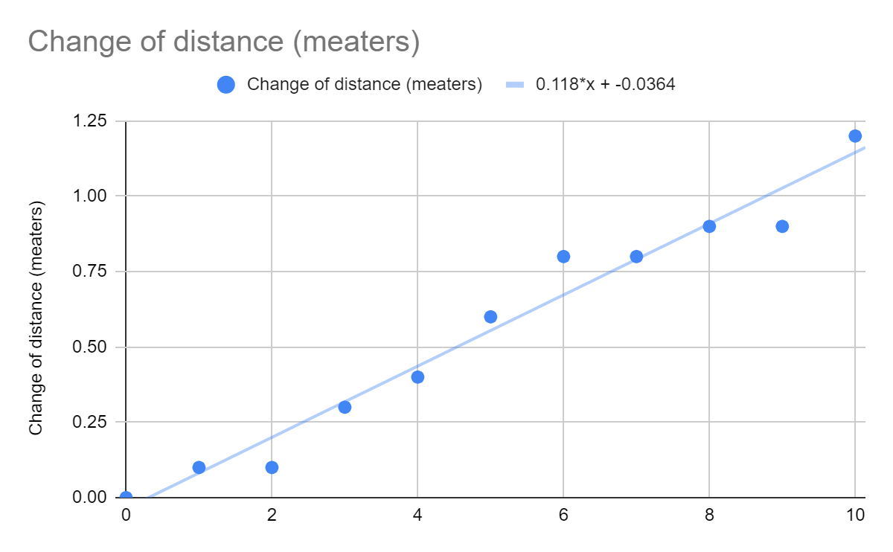

Slope is around 0.118

**Analysis and Conclusion**

1. Divide the force you used (in Newtons) by the mass of the skateboard + sitter (in kg). The product is your acceleration in m/s2. (Because **F = ma**)
   1. How does the acceleration you just calculated compare to the acceleration you got from your graph?

The acceleration of the calculations is not congruent with the calculation of the acceleration of the graph the graph is .118 and the equation is .14.

* 1. They should be identical - why do you think they are not?

I'm not completely sure why the answers are not the same but I would guess that they are different because the equation of the line made through the scatter chart is not exactly accurate because it makes an estimation not an exact value.

1. If you push or pull on an object with a steady force, how does its position change over time?

The position of the object will increase over time because the force builds up over time and with each unit of time the object will travel further.

1. How does its velocity change over time?

The velocity of the object increases over time

1. What about its acceleration?

The acceleration of the object also increases

1. Have you ever seen a slope before in math class?

Yes, I have worked will slopes a lot in math

1. What did the slope tell us in this activity?

The slope told us the average distance ( better known and the change of distance)

1. How would this experiment be different if the sitter was twice as heavy?

The experiment's values would be completely different, the acceleration would most likely have a more drastic charge ( start slower, and get faster)and overall get much slower- the slope would be around 0.0704

How would this experiment be different if the sitter was twenty kg lighter?

The reverse of the last answer will happen the the velocity will be much greater ( the slope will be around 0.196)

How would this experiment be different if you pulled twice as hard?

The velocity and acceleration would increase - slope( acceleration) would be 0.282

How would this experiment be different if you pulled with only eight Newtons?

The velocity and acceleration would decrease - slope would be around 0.113

. Show sample calculations to support your answers in Question 7.

1. A= F/M A= (10) Newtons/ 71(2) Kg A= 10/142 A= 0.0704
2. A= F/M A= (10) Newtons/ 71- (20) Kg A= 10/51 A= 0.196
3. A= F/M A= (10)(2) Newtons/ 71 Kg A= 20/71 A= 0.282
4. A= F/M A= (10)-(2) Newtons/ 71 Kg A= 8/71 A= 0.113

